Software Requirements Specification
For
<Monitoring and Evaluation System for ICCR’s Regional Offices (ROs)>
Version 1.0 approved
Prepared by <author>
<organization>
<date created>
Table of Contents
Table of Contents ii
Revision History ii
1. Introduction 1
1.1 Purpose 1
1.2 Document Conventions 1
1.3 Intended Audience and Reading Suggestions 1
1.4 Product Scope 1
1.5 References 1
2. Overall Description 2
2.1 Product Perspective 2
2.2 Product Functions 2
2.3 User Classes and Characteristics 2
2.4 Operating Environment 2
2.5 Design and Implementation Constraints 2
2.6 User Documentation 2
2.7 Assumptions and Dependencies 3
3. External Interface Requirements 3
3.1 User Interfaces 3
3.2 Hardware Interfaces 3
3.3 Software Interfaces 3
3.4 Communications Interfaces 3
4. System Features 4
4.1 System Feature 1 4
4.2 System Feature 2 (and so on) 4
5. Other Nonfunctional Requirements 4
5.1 Performance Requirements 4
5.2 Safety Requirements 5
5.3 Security Requirements 5
5.4 Software Quality Attributes 5
5.5 Business Rules 5
6. Other Requirements 5
Appendix A: Glossary 5
Appendix B: Analysis Models 5
Appendix C: To Be Determined List 6

Revision History
Name | Date | Reason For Changes | Version

Introduction

Purpose
ICCR main objective is to monitor all its Regional Offices (ROs) in India on real-time basis for all the activities they conduct, which would ultimately help ICCR to implement its activities effectively and efficiently and thus, evaluate their performances on real-time basis.

Document Conventions

Intended Audience and Reading Suggestions
The intended audience who will be mainly using our system are:
ICCR, ROs, Institutes and Students.
- ICCR is the primary stakeholder with a separate dashboard to manage Regional Offices and evaluate their activities.
- RO’s will be provided with a dashboard to schedule activities, upload reports for the activities conducted and manage students and handle their grievances.
- Institutes will be provided funds by the ICCR to conduct cultural events at the institute level.
- Students can give feedback of the events conducted in their institutes.

Product Scope
Monitoring and evaluating all activities of ICCR’s Regional Offices and evaluate their performances on real-time basis.
- Look after the interest of foreign students studying in various states of India.
- Keep track of Monetary Information spent on students and other establishment expenditure.
- Develop mechanism to coordinate with local cultural and educational organizations and the State Government for carrying out ICCR’s based activities.

References
- Indian Council for Cultural Relations, Wikipedia, https://en.wikipedia.org/wiki/Indian_Council_for_Cultural_Relations#Publications, Oct 3,2022
- Official website of Indian Council for Cultural Relations, Government of India, https://iccr.gov.in/about-us, Oct 3,2022
- ICCR Annual Report: Indian Council for Cultural Relations Azad Bhawan, I.P. Estate, New Delhi, 2020-21

Overall Description

Product Perspective
It is a web portal with separate dashboards for each stakeholder ICCR, ROs, Institutes and Students whose main objective is to monitor and evaluate the cultural activities in the institutes and provide them with funds and special performance ratings for conducting ICCR events.
At the same time making the Indian students aware about Indian cultures as well as the foreign students by proving them with scholarships to study our culture in India.
Its objectives are to actively participate in the formulation and implementation of policies and programmes pertaining to India's external cultural relations, to foster and strengthen cultural relations and mutual understanding between India and other countries and to promote cultural exchanges with other countries

Product Functions
Main Functionalities of this portal are:
Facility of generating the monthly activity report based on activities conducts or events organized at the institute level.
Generating feedback form links for sharing it amongst participants of events to collect their review and feedback of the events organized to better perform next time.

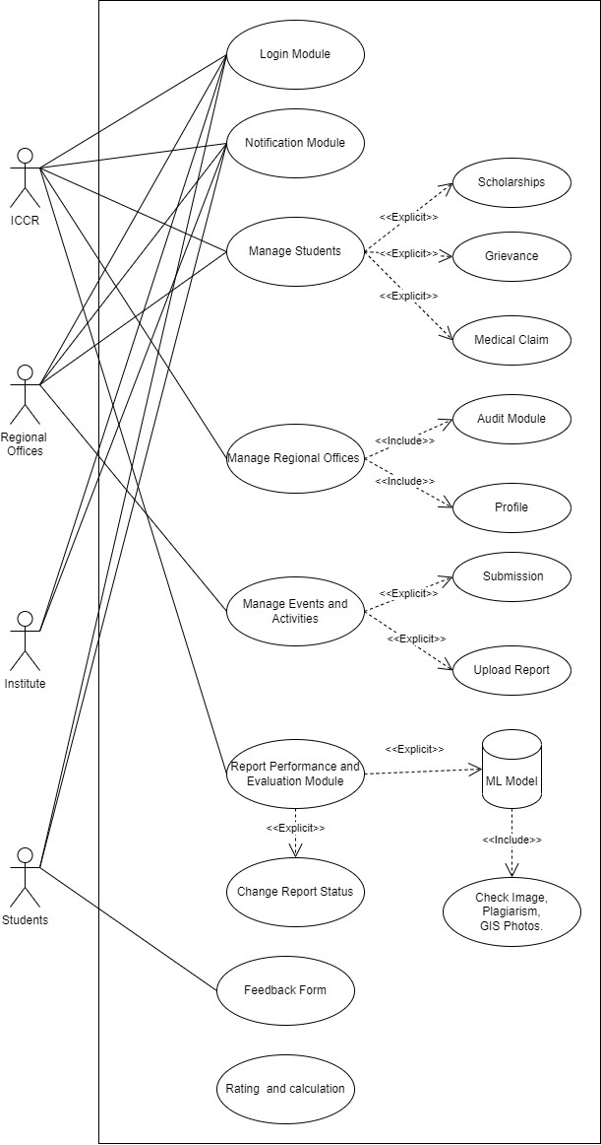
User Classes and Characteristics

Operating Environment
Our website can smoothly work on both windows and mac-os operating systems.

Design and Implementation Constraints
Since the entire website is in only one language i.e English it might be difficult for other people speaking different languages.

Assumptions and Dependencies
It is already assumed that all the stakeholders ICCR, ROs, Institutes and Students are already registered on the web portal.
Internet connectivity and OS like Windows or Mac-OS can some of the dependencies.

External Interface Requirements

User Interfaces
All stakeholders have separate dashboard and navigate easy or for smooth flow.

Communications Interfaces

Communication channel between all the stockholders for effective running of the system.
And also for checking that the information provides is authentic for not.

System Features
<This template illustrates organizing the functional requirements for the product by system features, the major services provided by the product. You may prefer to organize this section by use case, mode of operation, user class, object class, functional hierarchy, or combinations of these, whatever makes the most logical sense for your product.>

Functioanl
<Don’t really say “System Feature 1.” State the feature name in just a few words.>
4.1.1 Description and Priority
<Provide a short description of the feature and indicate whether it is of High, Medium, or Low priority. You could also include specific priority component ratings, such as benefit, penalty, cost, and risk (each rated on a relative scale from a low of 1 to a high of 9).>
4.1.2 Stimulus/Response Sequences
<List the sequences of user actions and system responses that stimulate the behavior defined for this feature. These will correspond to the dialog elements associated with use cases.>
4.1.3 Functional Requirements
<Itemize the detailed functional requirements associated with this feature. These are the software capabilities that must be present in order for the user to carry out the services provided by the feature, or to execute the use case. Include how the product should respond to anticipated error conditions or invalid inputs. Requirements should be concise, complete, unambiguous, verifiable, and necessary. Use “TBD” as a placeholder to indicate when necessary information is not yet available.>

<Each requirement should be uniquely identified with a sequence number or a meaningful tag of some kind.>

REQ-1: communication channel between all stake holders:
REQ-2: evaluate the events
Rating mechanism
Monitoring the RO

System Feature 2 (and so on)

Other Nonfunctional Requirements

Performance Requirements
<If there are performance requirements for the product under various circumstances, state them here and explain their rationale, to help the developers understand the intent and make suitable design choices. Specify the timing relationships for real time systems. Make such requirements as specific as possible. You may need to state performance requirements for individual functional requirements or features.>

Time constraint (10 sec), system size, smooth working of the website

Safety Requirements
<Specify those requirements that are concerned with possible loss, damage, or harm that could result from the use of the product. Define any safeguards or actions that must be taken, as well as actions that must be prevented. Refer to any external policies or regulations that state safety issues that affect the product’s design or use. Define any safety certifications that must be satisfied.>

Security Requirements
<Specify any requirements regarding security or privacy issues surrounding use of the product or protection of the data used or created by the product. Define any user identity authentication requirements. Refer to any external policies or regulations containing security issues that affect the product. Define any security or privacy certifications that must be satisfied.>

Students should be registered in the institute, same for all stake holders

Software Quality Attributes
<Specify any additional quality characteristics for the product that will be important to either the customers or the developers. Some to consider are: adaptability, availability, correctness, flexibility, interoperability, maintainability, portability, reliability, reusability, robustness, testability, and usability. Write these to be specific, quantitative, and verifiable when possible. At the least, clarify the relative preferences for various attributes, such as ease of use over ease of learning.>

Maps, maintain the webportal by software developers.

Other Requirements
<Define any other requirements not covered elsewhere in the SRS. This might include database requirements, internationalization requirements, legal requirements, reuse objectives for the

project, and so on. Add any new sections that are pertinent to the project.>
Appendix A: Glossary
<Define all the terms necessary to properly interpret the SRS, including acronyms and abbreviations. You may wish to build a separate glossary that spans multiple projects or the entire organization, and just include terms specific to a single project in each SRS.>

ICCR:
RO:
Appendix B: Analysis Models
<Optionally, include any pertinent analysis models, such as data flow diagrams, class diagrams, state-transition diagrams, or entity-relationship diagrams.>

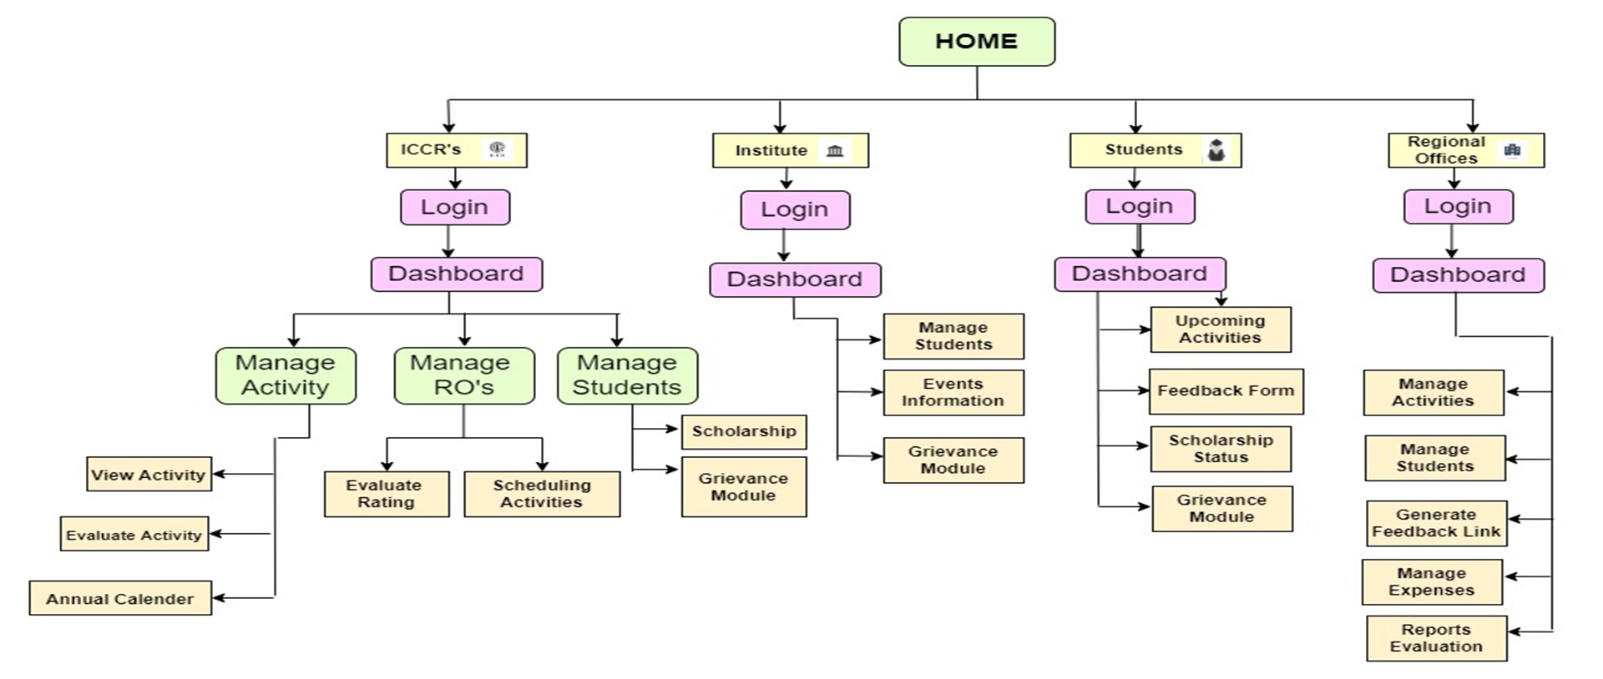
Appendix C: To Be Determined List
<Collect a numbered list of the TBD (to be determined) references that remain in the SRS so they can be tracked to closure.>

